RePlastix Innovations: Transforming Plastic Waste into Sustainable Solutions-
Salesforce

Project Overview
Replastix Innovations Salesforce Automation System is a cloud-based CRM solution built on the Salesforce platform to manage and automate plastic recycling operations, inventory control, order processing, and replenishment workflows. The system is designed to support Replastix Innovations’ mission of sustainable waste management by providing a secure, scalable, and automated solution that enhances operational efficiency and data visibility across departments.
By leveraging Salesforce’s powerful data modeling, security framework, automation tools, and Apex development capabilities, the system ensures real-time monitoring of recycled product stock, automated handling of low inventory situations, streamlined order management, and proactive communication with warehouse and operations teams.

Objectives
- Automate Inventory Management
Design an intelligent inventory tracking system that continuously monitors stock levels of recycled products and automatically triggers actions when stock falls below predefined thresholds.
- Streamline Order and Restock Processes
Automate order processing and low-stock handling by generating replenishment requests and updating order statuses without manual intervention.
- Implement Secure Role-Based Access

Ensure data security by configuring Salesforce roles, profiles, and permission sets so that users access only the data relevant to their responsibilities.
- Enable Proactive Notifications
Automatically notify warehouse managers via email when restock requests are approved, ensuring timely stock replenishment and smooth warehouse operations.
- Enhance Operational Visibility
Provide accurate and structured data that supports reporting and analytics for inventory performance, order trends, and sustainability tracking.

Key Features
- Custom objects for recycled products, orders, and restock requests
- Automated stock-level validation and threshold monitoring
- Apex triggers for real-time inventory updates
- Automated restock request creation and approval handling
- Email notifications for warehouse operations
- Secure data access using Salesforce security model
- Scalable architecture suitable for growing recycling operations

Student Outcomes
- Hands-on Salesforce Development Experience
Students gain practical experience in building a real-world automation system using Salesforce objects, Apex classes, triggers, and email services.
- End-to-End CRM Implementation Knowledge
Students understand the full Salesforce development lifecycle — from data modeling and security configuration to automation, testing, and deployment.

- Advanced Automation Skills
Students learn to design and implement automation using Apex triggers, business logic classes, and approval-based workflows.
- Strong Understanding of Data Security
Students gain experience in applying Salesforce’s role hierarchy, profiles, and field-level security to protect sensitive operational data.
- Improved Problem-Solving and Debugging Skills
Students enhance their ability to analyze business requirements, translate them into technical solutions, and debug complex Apex logic effectively.

System Requirements
Hardware Requirements
- Computer with minimum 4 GB RAM
- Dual-core processor or higher
- Stable internet connection
Software Requirements
- Salesforce Developer Edition Org
- Modern Web Browser (Google Chrome / Mozilla Firefox)

Skills Required
- Salesforce Platform Fundamentals
- Salesforce Data Modeling and Relationships
- Salesforce Security (Roles, Profiles, Permission Sets)
- Apex Programming and Triggers
- Flow Builder and Automation Concepts
- Email Services and Notifications
- Reporting and Analytics

Phases Overview:

Phase No. | Phase Name | Description | Page Numbers
1 | Requirement Analysis & Planning | Define business requirements, project scope, Salesforce architecture, and data model design. | 7- 12
2 | Salesforce Development - Backend & Configurations | Set up objects, fields, automation, and Apex logic. | 12 - 25
3 | UI/UX Development & Customization | Design intuitive interfaces using Lightning Components and Flows. | 25 – 32
4 | Data Migration, Testing & Security | Migrate data, test functionality, and enforce data security. | 33- 53
5 | Deployment, Documentation & Maintenance | Deploy the solution, train users, maintain system health, resolve issues, Documentation. | 54- 70

Project Main Overview
The Replastix Innovations Salesforce Automation System is an end-to- end Salesforce-based solution designed to automate and optimize core business operations in plastic recycling and waste management. The system centralizes critical processes such as recycled product
management, order processing, inventory tracking, restock approvals, and operational reporting within a unified Salesforce platform. This solution enables Replastix Innovations to efficiently manage recycling workflows while maintaining high standards of data accuracy and security.
The system enhances operational efficiency by automating inventory monitoring and order handling through Apex triggers, Flows, and custom business logic. Stock levels are continuously tracked, and when
predefined thresholds are breached, the system automatically initiates corrective actions such as task creation, restock request generation, and order status updates. Approval workflows ensure that replenishment requests are reviewed and authorized before stock levels are updated, minimizing manual intervention and operational delays.
Managers and operational teams gain real-time visibility into inventory status, orders, and replenishment requests through structured records and reports. Automated email notifications further improve coordination by informing warehouse managers immediately upon restock approval.
Employees across departments interact with a secure, role-based Salesforce interface tailored to their responsibilities, ensuring clarity and efficiency in day-to-day operations.
By leveraging Salesforce core platform capabilities — including custom objects, Apex automation, Flow Builder, and reporting tools — the Replastix Innovations system reduces manual effort, improves data consistency, and supports sustainable operational practices. A robust security model implemented through roles, profiles, and field-level
permissions ensures that sensitive data is protected while enabling
seamless collaboration across departments. Overall, the solution delivers a scalable, secure, and intelligent Salesforce ecosystem that supports

Replastix Innovations’ mission of efficient and sustainable waste management.

Main Objectives
The primary objective of the Replastix Innovations Salesforce
Automation System is to deliver a centralized, secure, and scalable Salesforce solution that automates recycling operations, inventory
control, and order management while improving operational visibility and decision-making.
- Centralized Recycling Operations: Establish a unified Salesforce
platform to manage recycled products, inventory records, orders, restock requests, and operational tasks within a single system.
- Automated Inventory Monitoring: Continuously track stock levels and automatically trigger actions such as task creation and replenishment requests when predefined threshold limits are crossed.
- Streamlined Order & Restock Workflows: Automate order updates and restock request generation to ensure uninterrupted operations and timely procurement of recycled materials.
- Approval-Based Stock Management: Implement approval workflows for replenishment requests to ensure controlled and authorized inventory updates.
- Real-Time Notifications: Automatically notify warehouse managers via email when restock requests are approved, enabling immediate stock replenishment actions.
- Role-Based Data Security: Enforce robust access control using Salesforce roles, profiles, and field-level security to protect sensitive operational and inventory data.
- Operational Visibility & Reporting: Enable comprehensive reporting and dashboards to track inventory trends, order fulfillment, stock
shortages, and sustainability performance metrics.

- Scalable Salesforce Architecture: Design a future-ready system capable of supporting growing operational demands and additional automation enhancements.

Phase 1: Requirement Analysis & Planning

- Understanding Business Requirements Objective:
To understand how Replastix Innovations manages its plastic recycling operations, inventory control, order processing, and stock replenishment activities. Identify challenges in manual inventory tracking, delayed
restocking, lack of real-time visibility, and the need for an automated, centralized Salesforce-based solution.
Approach:
  - Conduct discussions with operations teams, warehouse staff, inventory managers, and procurement teams to understand existing workflows and operational challenges.
  - Analyse current processes related to recycled product inventory, order creation, stock monitoring, and restock approvals.
  - Identify inefficiencies such as delayed stock updates, manual follow-ups, and lack of automated alerts.
  - Study Salesforce best practices for inventory automation, Apex triggers, approval workflows, and reporting.
  - Refer to Salesforce documentation, Trailhead modules, and online
learning resources (including ChatGPT and Google) to design an efficient and scalable solution.

Key Business Requirements Identified:
- Track recycled product stock levels in real time within Salesforce.

- Automatically detect low stock situations based on predefined threshold values.
- Generate automated tasks and replenishment requests when stock levels fall below threshold.
- Update order records dynamically based on inventory availability.
- Route replenishment requests for approval before updating stock levels.
- Send automated email notifications to warehouse managers upon restock approval.
- Ensure secure access to inventory and order data through roles, profiles, and field-level security.
- Enable reporting and dashboards for monitoring inventory performance and operational KPIs.

- Defining Project Scope & Objectives Project Scope:
- Develop a centralized Salesforce system for managing recycled products, inventory, and orders.
- Automate inventory threshold monitoring and low-stock handling.
- Implement automated restock request generation and approval workflows.
- Integrate email notifications for warehouse and operations teams.
- Build a secure data access model for different operational roles.
- Enable reporting and analytics for inventory tracking and sustainability insights.

Objectives Summary:

- Reduce manual inventory tracking and operational delays.
- Ensure timely replenishment of recycled products.
- Improve visibility into inventory and order status across departments.
- Strengthen data security using Salesforce access control mechanisms.
- Deliver a scalable and automation-driven Salesforce solution to support sustainable waste management operations.

- Gathering & Analyzing User Needs Users Involved:
  - Operations Team: Manage recycled products, inventory levels, and stock updates.
  - Warehouse Manager: Handle stock replenishment and warehouse operations.
  - Procurement Team: Process replenishment requests and approvals.
  - Admin Team: Manage system configuration, security, and reporting.
  - System Administrator: Configure automation, Apex logic, and data access controls.

Key Functional Needs:
  - Automated inventory monitoring with threshold-based alerts.
  - Seamless order creation and updates linked to product stock levels.
  - Automated restock request generation for low-stock items.
  - Approval workflow for restock requests before updating inventory.
  - Email notifications for approved replenishment actions.
  - Role-based access to restrict sensitive inventory and order data.
  - Reports and dashboards for inventory trends, shortages, and performance metrics.

- Identifying Key Salesforce Features & Tools Required Salesforce Features Planned:
  - Custom Objects:
- Recycled_Product c
- Order c
- Restock_Request c
  - Standard Objects:
- Task
- User
  - Automation:
- Apex Triggers for inventory and order processing
- Approval-based automation for restock requests
- Email alerts using Salesforce Messaging
  - Apex:
- Business logic for stock reduction, replenishment handling, and approvals
  - Security:
- Profiles, Roles, Permission Sets
- Field-Level Security
- Sharing Rules
  - Reporting:
- Inventory status reports
- Order and replenishment tracking dashboards

- Designing Data Model and Security Model Data Model Includes:
  - Recycled_Product c (Custom Object):
    - Stores product details such as product name, stock level, threshold value, and owner.
    - Acts as the central object for inventory tracking and automation.
  - Order c (Custom Object):
    - Stores order details including product reference, quantity, and order status.
    - Linked to Recycled_Product c to update stock levels automatically.
  - Restock_Request c (Custom Object):
    - Created automatically when stock is insufficient.
    - Tracks requested quantity, approval status, and linked product.
  - Task (Standard Object):
    - Automatically created when stock falls below threshold.
    - Assigned to the product owner for immediate action.

Security Model Design:
  - Roles: Admin, Operations Manager, Warehouse Manager
  - Profiles: System Admin Profile, Operations Profile, Warehouse Profile
  - Permission Sets: Additional access such as “Approve Restock Requests” or “View Inventory Reports.”
  - Sharing Rules: Ensure managers can view all inventory and restock requests while restricting standard users to relevant records.
  - Field-Level Security: Protect sensitive inventory and operational fields.

Summary:
This phase established a comprehensive understanding of Replastix Innovations’ operational challenges and defined a clear roadmap for implementing an automated, secure, and scalable Salesforce-based inventory and order management system. The requirement analysis ensured that the solution would reduce manual effort, improve stock
availability, and enhance decision-making through real-time automation and reporting.

Phase 2: Salesforce Development – Backend & Configurations
The Backend & Configuration phase focused on building the core automation engine of the Replastix Innovations Salesforce System. Using a combination of Apex classes, triggers, approval logic, email
notifications, and security configurations, a robust backend was
developed to handle inventory monitoring, order processing, restock approvals, and stock updates.
The system leverages Apex triggers to monitor stock levels in real time and initiate automated actions when threshold limits are breached.
Business logic is encapsulated in Apex classes to ensure reusability, bulk safety, and maintainability. Approval-based workflows control restock requests, ensuring inventory updates occur only after proper
authorization.
Security configurations using profiles, roles, permission sets, and field- level security ensure that sensitive operational data remains protected while enabling efficient collaboration. Reporting and dashboards were configured to provide real-time insights into inventory health and
operational performance.
This phase transformed business requirements into a fully functional Salesforce backend, forming the foundation for reliable automation, scalability, and future enhancements.

Milestone 1: Salesforce Developer Account Setup

Introduction
Salesforce is one of the world’s leading cloud-based platforms used for building scalable business applications and CRM solutions. For students and beginners, the first step in learning Salesforce development is
creating a Salesforce Developer Account, which provides a free environment to practice configuration, automation, and Apex development.
This milestone introduces learners to Salesforce and guides them through the process of creating and activating a Salesforce Developer Edition account. The Developer Edition offers full access to Salesforce
features, allowing users to explore real-world application development without any cost.

What Is a Salesforce Developer Account?
A Salesforce Developer Account (Developer Edition Org) is a free
Salesforce environment designed for learning, testing, and application development. It allows users to:
- Create custom objects and fields
- Write and test Apex code and triggers
- Build automation using Flows
- Configure security using profiles and roles
- Practice real-time Salesforce development scenarios
This account is essential for students and developers to gain hands-on experience with the Salesforce platform.

Activity 1: Creating a Salesforce Developer Account

Objective:
To create a Salesforce Developer Edition account that will be used
throughout the project for development, testing, and learning purposes. Steps to Create a Developer Account:
- Open a web browser and go to:
https://developer.salesforce.com/signup
- On the sign-up form, enter the following details:
  - First Name & Last Name – Enter your full name
  - Email – Enter a valid email address (used for account activation)
  - Job Title / Role – Select Developer
  - Company – Enter your College Name
  - Country – Select India
  - Postal Code – Enter your area PIN code
  - Username – Create a unique username (recommended format: yourname_college@developer.com)
- After filling in all the required details, click on Sign Me Up.
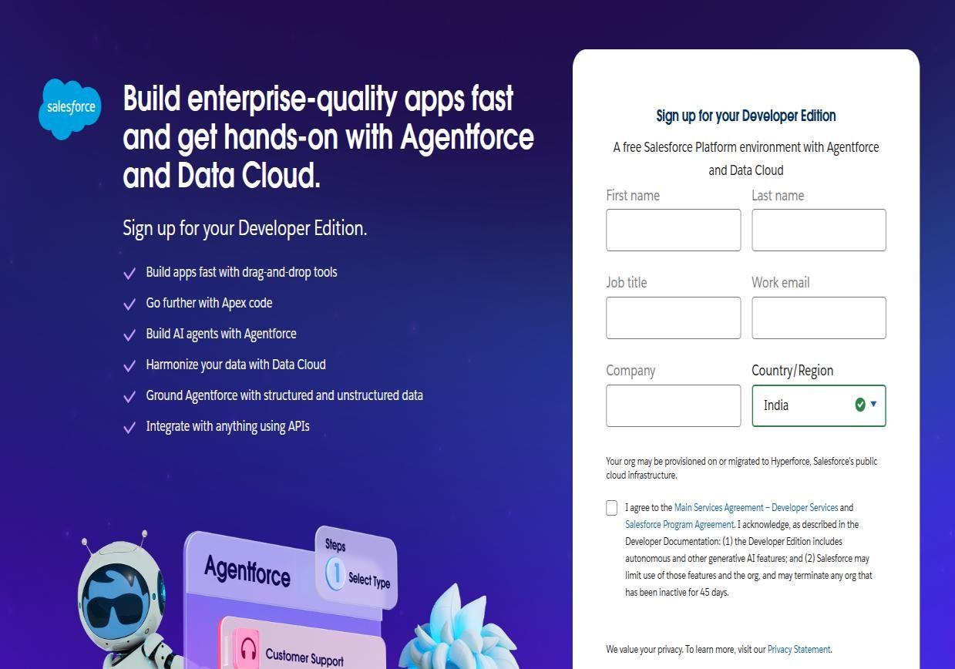

Activity 2: Account Activation
Objective:
To activate the Salesforce Developer Account and access the Salesforce setup environment.
Steps to Activate the Account:
- Open the inbox of the email address used during registration.
(Note: The activation email may take 10–30 minutes and, in some cases, up to 2 hours.)
- Locate the email from Salesforce and click on Verify Account.
- On the activation page:
  - Set a password
  - Choose and answer a security question
  - Click on Change Password
- Once completed, you will be automatically redirected to the
Salesforce Setup Page, indicating that your Developer Account has been successfully activated.
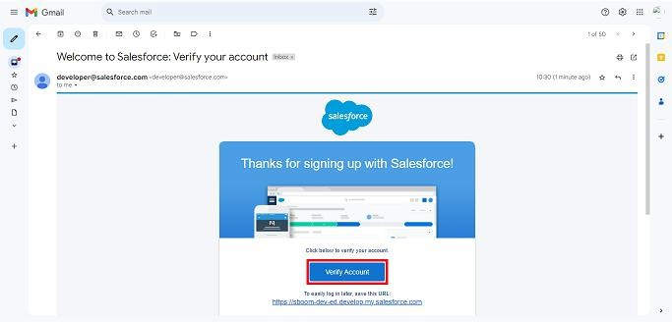

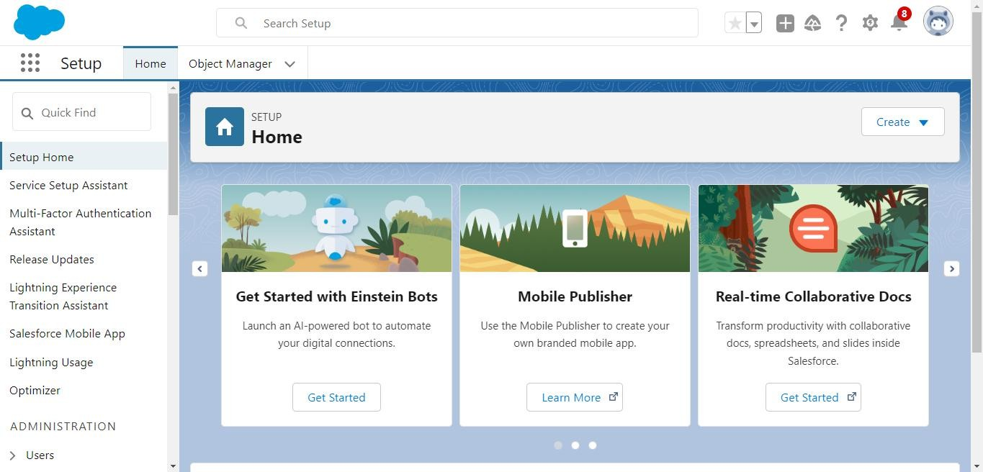

Outcome of This Milestone
By completing this milestone, learners will:
- Successfully create a Salesforce Developer Edition account
- Gain access to the Salesforce setup and development environment
- Be ready to begin hands-on Salesforce configuration, automation, and development activities

Milestone 2: Objects & Relationships Design

Introduction
In Salesforce, objects and relationships form the foundation of any application. For the Replastix Innovations Salesforce Automation
System, custom objects are designed to accurately represent real-world entities such as plastic waste, recycling centers, recycled products, orders, and restock requests. A well-structured data model ensures
efficient data storage, secure access, seamless automation, and meaningful reporting.

This milestone focuses on designing and creating the required custom objects and defining relationships between them to support inventory management, recycling operations, and order processing.
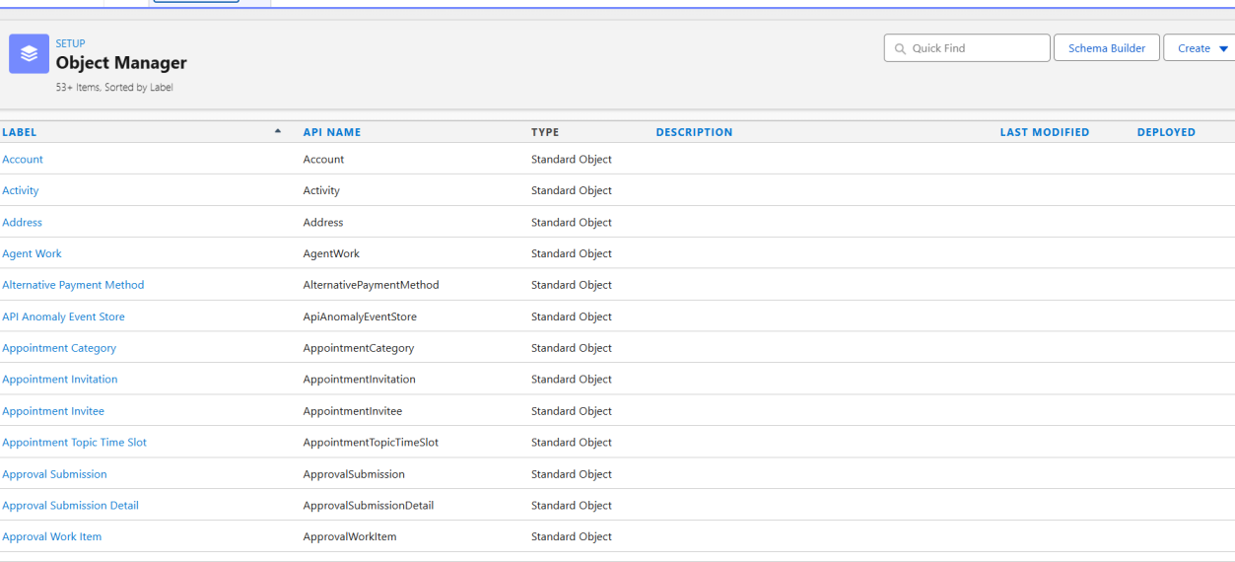

Custom Objects Overview
- Re Plastic Innovations Plastic Waste
API Name: Re_Plastic_Innovations_Plastic_Waste c
This object stores detailed information about collected plastic waste and tracks its lifecycle from collection to recycling.

Field API Name | Data Type | Description
Name | Auto Number | Unique ID for waste records
Weight c | Number (18,2) | Weight of plastic waste in kilograms
Type c | Picklist | Type of plastic (PET, HDPE, PVC, etc.)
Collection_Date c | Date | Date when the waste was collected

Field API Name | Data Type | Description
Status c | Picklist | Collected, Processing, Recycled
Recycling_Center c | Lookup  (Recycling_Center c) | Assigned recycling center
Location c | Geolocation | Waste collection location

- Re Plastic Innovations Recycling Center
API Name: Re_Plastic_Innovations_Recycling_Center c
This object represents recycling facilities responsible for processing plastic waste.

Field API Name | Data Type | Description
Name | Text | Recycling Center name
Location c | Geolocation | Location of the recycling center
Capacity c | Number (18,2) | Maximum waste processing capacity

- Re Plastic Innovations Recycled Product
API Name: Re_Plastic_Innovations_Recycled_Product c
This object manages recycled products generated from processed plastic waste.

Field API Name | Data Type | Description
Name | Text | Recycled product name
Stock_Level c | Number | Current available stock

Field API Name | Data Type | Description
Threshold c | Number | Minimum stock level before restock
Price c | Currency | Price per unit

- Re Plastic Innovations Order
API Name: Re_Plastic_Innovations_Order c
This object tracks customer orders for recycled products.

Field API Name | Data Type | Description
Name | Auto Number | Order ID
Customer c | Lookup (Account) | Customer placing the order
Recycled_Product c | Lookup  (Recycled_Product c) | Ordered product
Quantity c | Number | Quantity ordered
Delivery_Date c | Date | Expected delivery date

- Re Plastic Innovations Restock Request
API Name: Re_Plastic_Innovations_Restock_Request c
This object manages replenishment requests when stock levels fall below threshold.

Field API Name | Data Type | Description
Name | Auto Number | Restock Request ID

Field API Name | Data Type | Description
Product c | Lookup  (Recycled_Product c) | Product to be restocked
Requested_Quantity c | Number | Quantity requested
Status c | Picklist | Pending, Approved, Completed

Relationships Summary
  - Plastic Waste → Recycling Center (Lookup Relationship)
  - Orders → Recycled Product (Lookup Relationship)
  - Restock Request → Recycled Product (Lookup Relationship)
  - Orders → Account (Lookup Relationship)
These relationships enable seamless automation, reporting, and inventory tracking across the system.

Milestone 3: Create Re Plastic Innovations Plastic Waste Object
Purpose:
To store and manage information related to collected plastic waste. Steps to Create the Object:
- Go to Setup → Object Manager
- Click Create → Custom Object
- Enter the following details:
  - Label: Re Plastic Innovations Plastic Waste
  - Plural Label: Re Plastic Innovations Plastic Wastes
  - Record Name: Plastic Waste Name
  - Data Type: Auto Number

- Enable:
  - ☑ Allow Reports
  - ☑ Allow Search
- Click Save

Create Re Plastic Innovations Recycling Center Object Purpose:
To maintain details of recycling centers handling plastic waste. Steps to Create the Object:
- Go to Setup → Object Manager
- Click Create → Custom Object
- Enter the following details:
  - Label: Re Plastic Innovations Recycling Center
  - Plural Label: Re Plastic Innovations Recycling Centers
  - Record Name: Recycling Center Name
  - Data Type: Text
- Enable:
  - ☑ Allow Reports
  - ☑ Allow Search
- Click Save

Create Re Plastic Innovations Recycled Product Object Purpose:
To manage recycled products and track stock levels. Steps to Create the Object:

- Go to Setup → Object Manager
- Click Create → Custom Object
- Enter the following details:
  - Label: Re Plastic Innovations Recycled Product
  - Plural Label: Re Plastic Innovations Recycled Products
  - Record Name: Recycled Product Name
  - Data Type: Text
- Enable:
  - ☑ Allow Reports
  - ☑ Allow Search
- Click Save

Create Re Plastic Innovations Order Object Purpose:
To store and track customer orders for recycled products. Steps to Create the Object:
- Go to Setup → Object Manager
- Click Create → Custom Object
- Enter the following details:
  - Label: Re Plastic Innovations Order
  - Plural Label: Re Plastic Innovations Orders
  - Record Name: Order ID
  - Data Type: Auto Number
- Enable:
  - ☑ Allow Reports

  - ☑ Allow Search
- Click Save

Activity 5: Create Re Plastic Innovations Restock Request Object Purpose:
To manage stock replenishment requests for recycled products. Steps to Create the Object:
- Go to Setup → Object Manager
- Click Create → Custom Object
- Enter the following details:
  - Label: Re Plastic Innovations Restock Request
  - Plural Label: Re Plastic Innovations Restock Requests
  - Record Name: Restock Request ID
  - Data Type: Auto Number
- Enable:
  - ☑ Allow Reports
  - ☑ Allow Search
- Click Save

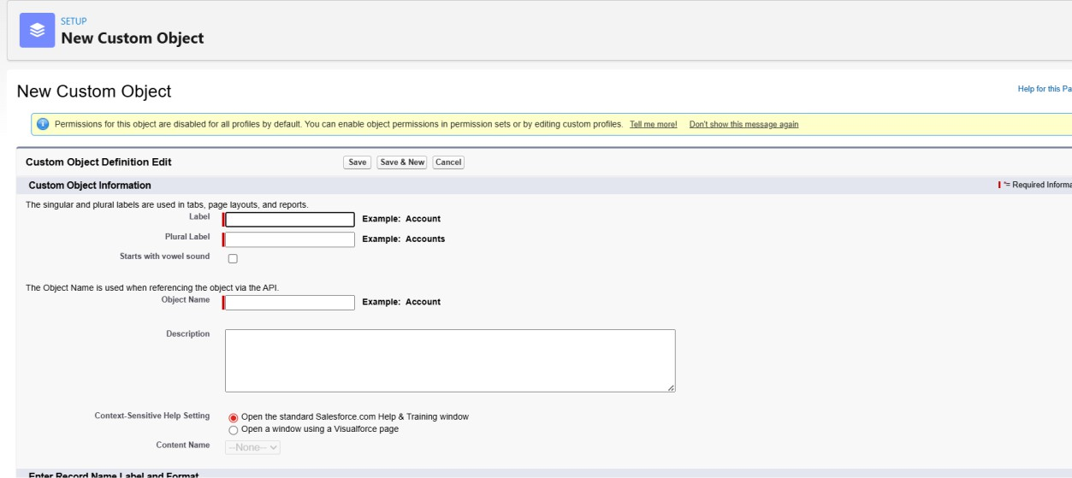

Milestone 4: Create Custom Tabs for Replastix Innovations Objects
Purpose:
To create custom tabs for all Replastix Innovations objects so that users can easily access and manage records from the Salesforce navigation bar.

Steps to Create Custom Tabs
- Go to Setup
- In the Quick Find box, type Tabs
- Click on Tabs
- Under Custom Object Tabs, click New
- Select the required Object
- Choose any Tab Style → Click Next
- On Add to Profiles page:
  - Keep the default selection → Click Next
- On Add to Custom Apps page:
  - Keep the default selection → Click Save

Custom Tabs Created
Repeat the above steps to create tabs for the following objects:
- Re Plastic Innovations Plastic Waste
- Re Plastic Innovations Recycling Center
- Re Plastic Innovations Recycled Product
- Re Plastic Innovations Order
- Re Plastic Innovations Restock Request
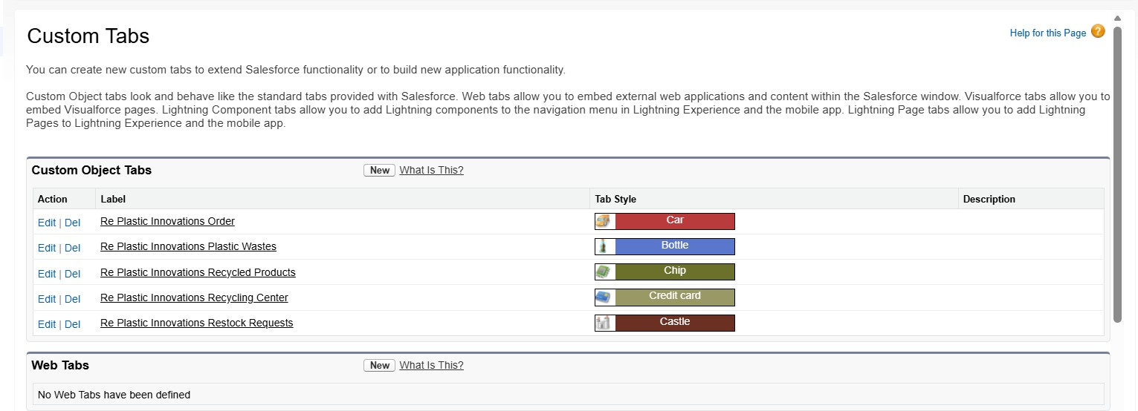

Outcome
Custom tabs are successfully created for all Replastix Innovations
objects, enabling easy navigation and efficient record management across the Salesforce application.

Phase 3 : UI/UX Development & Customization

Milestone 5: Create a Lightning App – Re Plastic Innovations
Purpose:
To create a custom Lightning App that provides a centralized workspace for managing Re Plastic Innovations objects such as Plastic Waste,
Recyclng Centers, Orders, and Restock Requests

Steps to Create a Lightning App
- Go to Setup
- In the Quick Find box, search for App Manager
- Click on App Manager
- Click New Lightning App

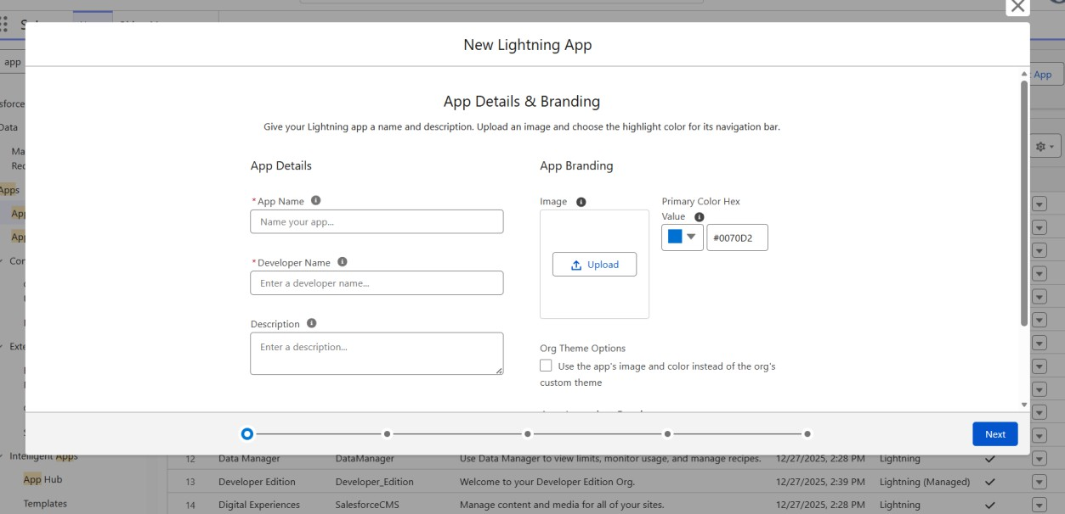

App Details & Branding
Enter the following details:
  - App Name: Re Plastic Innovations
  - Developer Name: Auto populated
  - Description: Enter a meaningful description related to plastic waste and recycling management
  - Image: Optional (can be skipped)
  - Primary Color: Keep default Click Next
App Options
- Keep all options as default
- Click Next

Utility Items
- Keep the default settings
- Click Next

Navigation Items
- In the Available Items search bar, search and add the following objects using the arrow button:
  - Restock Requests
  - Recycling Centers
  - Recycled Products
  - Plastic Wastes
  - Orders
- Click Next
Note: Select only the custom objects created in the previous activities.

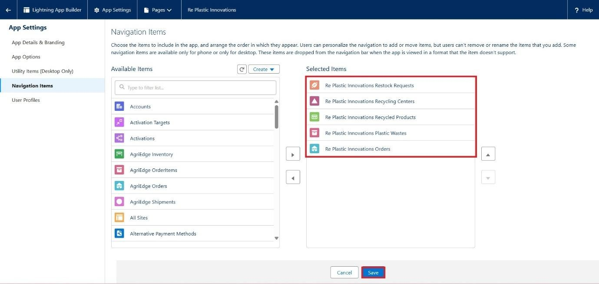

User Profile Assignment
- In the Available Profiles search bar, search for:
  - System Administrator
- Move it to Selected Profiles
- Click Save & Finish

Outcome
The Re Plastic Innovations Lightning App is successfully created, providing a unified interface for managing all recycling, inventory, order, and restock-related operations within Salesforce.

Key Fields for Each Object

Re Plastic Innovations Plastic Waste
API Name: Re_Plastic_Innovations_Plastic_Waste c

Field API Name | Data Type | Descriptio n
Name | Auto Number | Unique ID for waste records
Weight c | Number (18,2) | Weight of plastic  waste (kg)
Type c | Picklist | Type of plastic (PET, HDPE,  PVC, etc.)
Collection_Date c | Date | Date waste was  collected
Status c | Picklist | Collected, Processin g,  Recycled
Recycling_Center_  _c | Lookup  (Re_Plastic_Innovations_Recycling_Cente r c) | Assigned recycling center
Location c | Geolocation | Waste  collection location

Re Plastic Innovations Recycling Center

API Name: Re_Plastic_Innovations_Recycling_Center c

Field API Name | Data Type | Description
Name | Text | Recycling center name
Location c | Geolocation | Center’s location
Capacity c | Number (18,2) | Maximum capacity for processing waste

Re Plastic Innovations Recycled Product
API Name: Re_Plastic_Innovations_Recycled_Product c

Field API Name | Data Type | Description
Name | Text | Recycled product name
Stock_Level c | Number | Current stock available
Threshold c | Number | Minimum stock before restock is triggered
Price c | Currency | Price per unit

Re Plastic Innovations Order
API Name: Re_Plastic_Innovations_Order c

Field API Name | Data Type | Descripti on
Name | Auto Number | Order ID
Customer c | Lookup (Account) | Customer placing the order

Field API Name | Data Type | Descripti on
Recycled_Product  c | Lookup  (Re_Plastic_Innovations_Recycled_Produ ct c) | Ordered product
Quantity c | Number | Quantity ordered
Delivery_Date c | Date | Expected delivery date

Re Plastic Innovations Restock Request
API Name: Re_Plastic_Innovations_Restock_Request c

Field API Name | Data Type | Descripti on
Name | Auto Number | Restock request ID
Product c | Lookup  (Re_Plastic_Innovations_Recycled_Prod uct c) | Product to  restock
Requested_Quantit y c | Number | Quantity requeste d
Status c | Picklist | Pending, Approve d,

Field API Name | Data Type | Descripti on
 |  | Complete d

Phase 4: Data Migration, Testing & Security

Data Management – Fields
Common Steps to Create Any Field
- Go to Setup
- Click Object Manage
- Select the required Object
- Click Fields & Relationships
- Click New
- Choose Data Type
- Enter Field Label and Field Name
- Click Next → Next → Save

Fields to Create (Summary)
Re Plastic Innovations Plastic Waste
  - Weight c – Number (18,2)
  - Type c – Picklist (PET, HDPE, PVC)
  - Collection_Date c – Date
  - Status c – Picklist (Collected, Processing, Recycled)
  - Recycling_Center c – Lookup (Recycling Center)
  - Location c – Geolocation

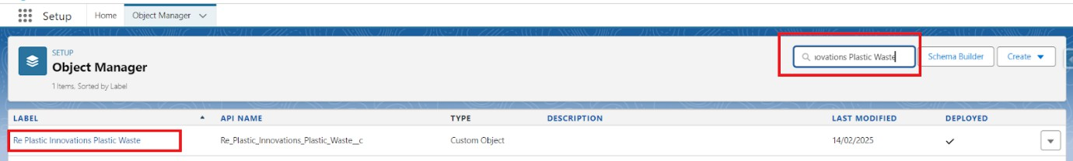

Re Plastic Innovations Recycling Center
  - Location c – Geolocation
  - Capacity c – Number (18,2)

Re Plastic Innovations Recycled Product
  - Stock_Level c – Number
  - Threshold c – Number
  - Price c – Currency

Re Plastic Innovations Order
  - Customer c – Lookup (Account)
  - Recycled_Product c – Lookup (Recycled Product)
  - Quantity c – Number
  - Delivery_Date c – Date

Re Plastic Innovations Restock Request
  - Product c – Lookup (Recycled Product)
  - Requested_Quantity c – Number
  - Status c – Picklist (Pending, Approved, Completed)

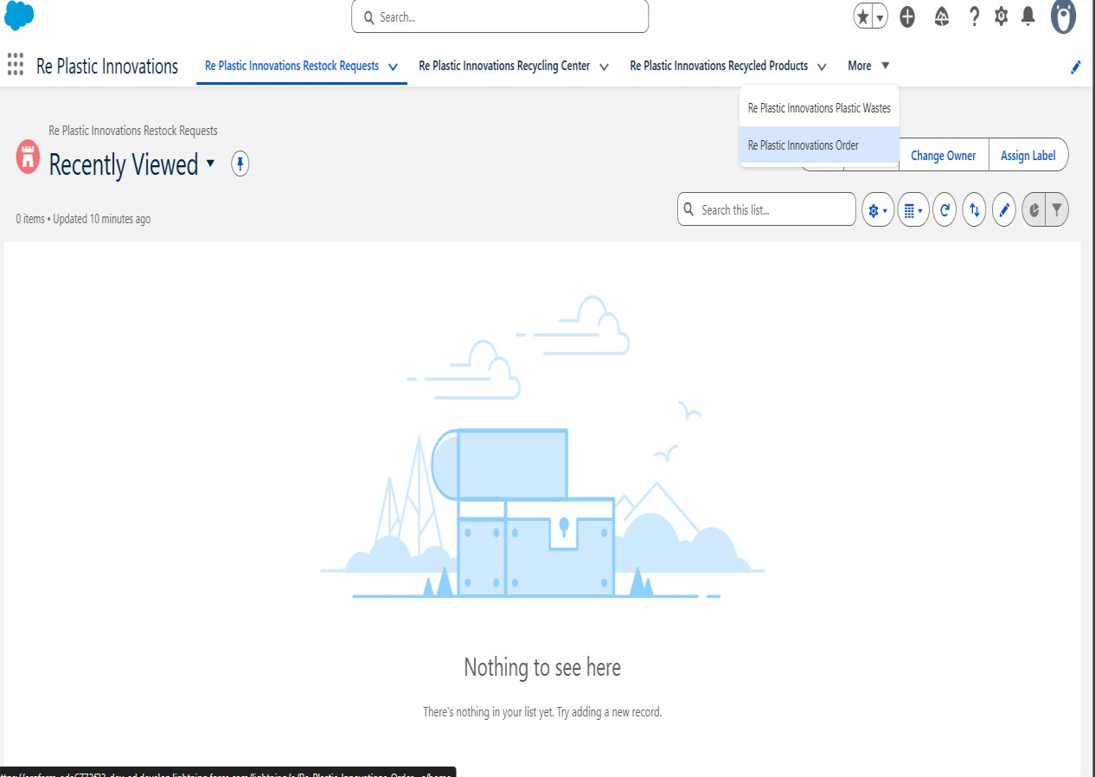
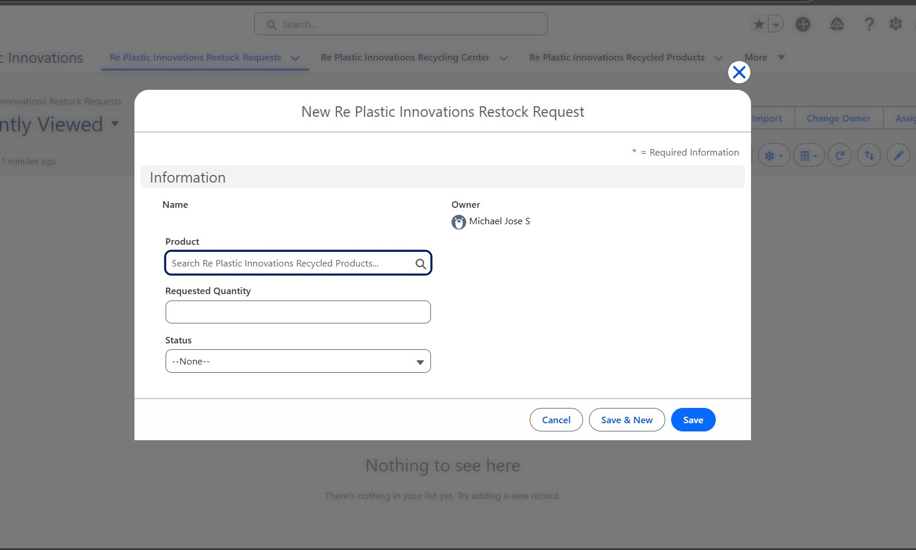
Outcome
All required fields are created, enabling structured data capture,
automation, and reporting across the Replastix Innovations Salesforce system.

Milestone 6: Create Roles – Recycling Manager, Sales
Representative, Warehouse Supervisor
Purpose:
To create a role hierarchy in Salesforce that supports structured access and reporting for recycling, sales, and warehouse operations.
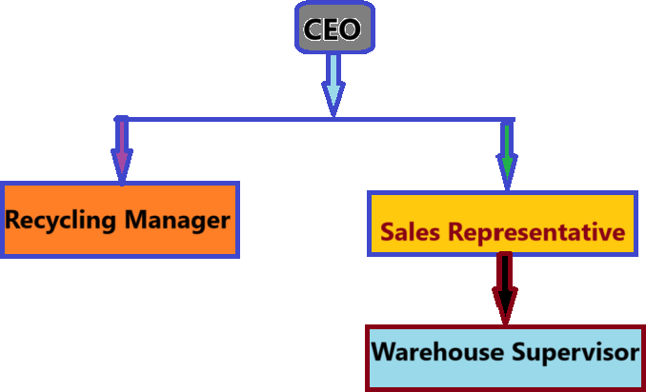

Steps to Create Roles
- Go to Setup
- In the Quick Find box, search for Roles
- Click Roles

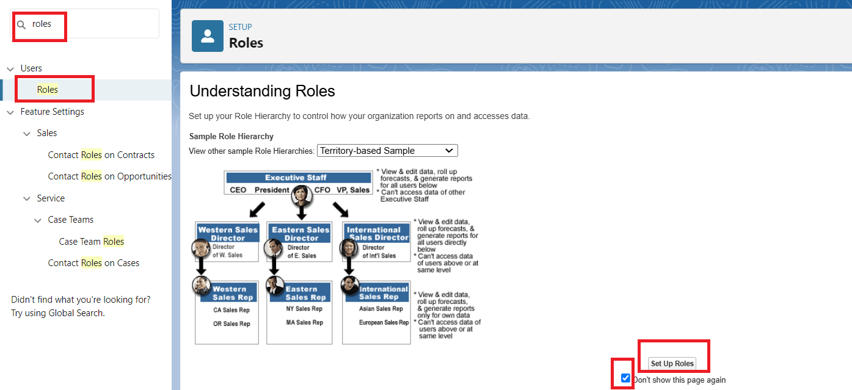

Role 1: Recycling Manager
- Under CEO, click Add Role
- Enter:
  - Label: Recycling Manager
  - This Role Reports To: CEO
- Click Save & New

Role 2: Sales Representative
- Under CEO, click Add Role
- Enter:
  - Label: Sales Representative
  - This Role Reports To: CEO
- Click Save & New

Role 3: Warehouse Supervisor
- Under Sales Representative, click Add Role

- Enter:
  - Label: Warehouse Supervisor
  - This Role Reports To: Sales Representative
- Click Save

Outcome
A structured role hierarchy is successfully created, ensuring proper data visibility and reporting flow within the Replastix Innovations Salesforce system.

Create Custom Profiles
Purpose:
To create custom Salesforce profiles to control object-level access for different users in the Replastix Innovations system.
Steps to Create Profile – Platform 1
- Go to Setup
- In the Quick Find box, search for Profiles
- Click on Profiles
- Click New Profile
- Fill the details as follows:
  - Existing Profile Name: Standard Platform User
  - User License: Salesforce Platform
  - Profile Name: Platform 1
- Click Save

Create Additional Profiles
Repeat the same steps to create the following profiles:
- Platform 2
- Platform 3

Activity: Modify Profile – Platform 1
Purpose:
To assign object-level access permissions for the Platform 1 profile. Steps:
- Go to Setup → Profiles
- Click on Platform 1
- Click Edit
- Under Object Settings, provide access as follows: Re Plastic Innovations Plastic Waste: Read, Create
Re Plastic Innovations Restock Request: Read Only
- Click Save

Activity: Assign Object-Level Access – Platform 2
Purpose:
To configure object access permissions for Platform 2 profile. Steps:
- Go to Setup → Profiles
- Click on Platform 2
- Click Edit
- Under Object Settings, provide access as follows: Read / Create Access:

  - Re Plastic Innovations Order
  - Account
Read Only Access:
  - Re Plastic Innovations Plastic Waste
  - Re Plastic Innovations Recycled Product
- Click Save

Activity: Assign Object-Level Access – Platform 3
Purpose:
To grant full access to all custom objects for Platform 3 profile. Steps:
- Go to Setup → Profiles
- Click on Platform 3
- Click Edit
- Under Object Settings, provide:
Read / Create / Edit Access to all Re Plastic Innovations custom objects
- Click Save
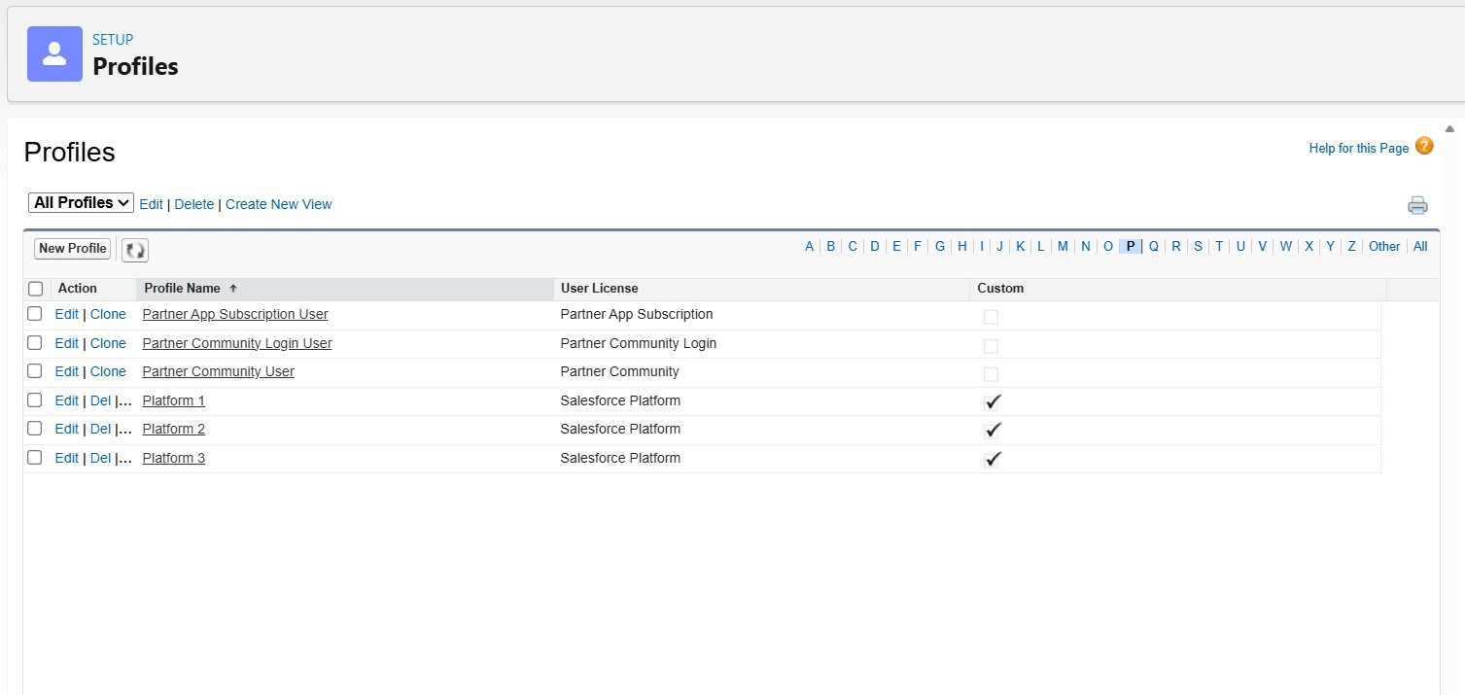

Outcome:
Three custom profiles are successfully created and configured with appropriate object-level permissions, ensuring secure and role-based access to data within the Replastix Innovations Salesforce application.

Milestone 7: Create Users – Replastix Innovations
Purpose:
To create Salesforce users and assign appropriate roles, profiles, and licenses to enable secure access to the Replastix Innovations
application.

User 1: John Production Engineer Steps to Create the User:
- Go to Setup
- In the Quick Find box, search for Users
- Click on Users
- Click New User
Fill Out User Information:
  - First Name: John Production Engineer
  - Last Name: Sandbox 1
  - Alias: Auto populated
  - Email: Enter your personal email ID
  - Username: JohnProductionEngineer@sandbox1.com
  - Role: Recycling Manager
  - Profile: Platform 1

  - User License: Salesforce Platform
- Click Save
Password Activation:
- Open the email inbox used during user creation
- Click Verify Account
- Click Reset Password
- Set a new password
- Click Change Password

User 2: Quality Inspector Steps to Create the User:
- Go to Setup → Users
- Click New User
Fill Out User Information:
  - First Name: Quality Inspector
  - Last Name: Mike
  - Alias: Auto populated
  - Email: Enter your personal email ID
  - Username: qualityinspector@sandbox1.com
  - Role: Sales Representative
  - Profile: Platform 2
  - User License: Salesforce Platform
- Click Save
Complete password setup using the email received.

User 3: Plant Manager
Steps to Create the User:
- Go to Setup → Users
- Click New User
Fill Out User Information:
  - First Name: Plant Manager
  - Last Name: Albert
  - Alias: Auto populated
  - Email: Enter your personal email ID
  - Username: plantmanager@sandbox1.com
  - Role: Warehouse Supervisor
  - Profile: Platform 3
  - User License: Salesforce Platform
- Click Save
Complete password setup using the email received.

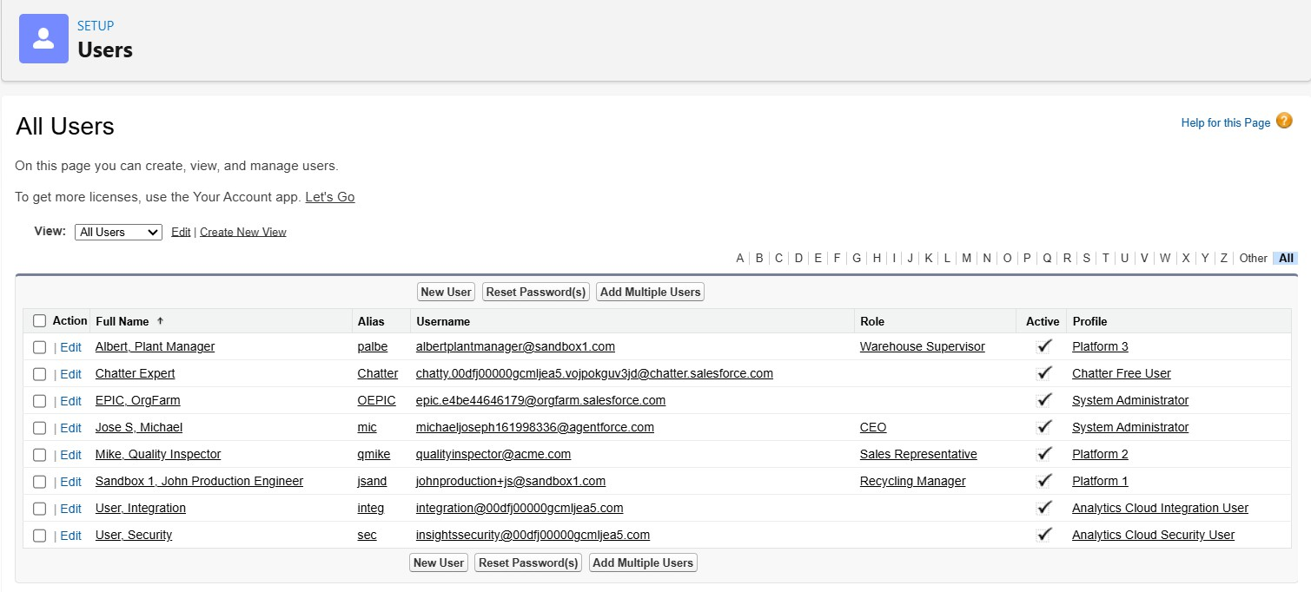

Outcome:
All three users are successfully created and activated with appropriate roles, profiles, and licenses, ensuring secure and role-based access to the Replastix Innovations Salesforce system.

Milestone 8: Sharing Settings – Record Level Access
Purpose:
To configure record-level access using Sharing Settings and Sharing Rules so that specific users can access records based on their roles within the Replastix Innovations Salesforce system.

Steps to Configure Organizational Wide Defaults (OWD):
- Go to Setup
- In the Quick Find box, search for Sharing Settings
- Click on Sharing Settings
- Click Edit
- Set the Organizational Wide Default (OWD) access for Re Plastic Innovations custom objects as required (Private or Read Only as per design)
- Click Save
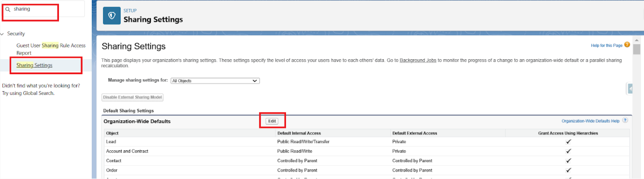

Activity: Create Sharing Rule – Recycling Manager Access

Purpose:
To allow only the Recycling Manager to access Plastic Waste collection details.
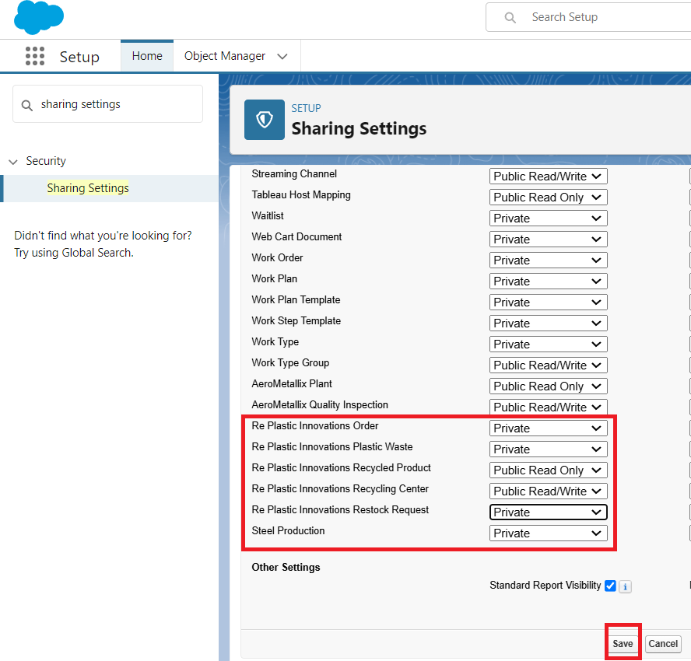
Steps:
- Go to Setup → Sharing Settings
- Scroll to Re Plastic Innovations Plastic Waste object
- Click New under Sharing Rules Enter the following details:
  - Label Name: Recycling Manager Access
  - Rule Name: Recycling_Manager_Access

  - Select which records should be shared: Records owned by CEO
  - Select the users to share with: Recycling Manager
  - Access Level: Read Only
- Click Save
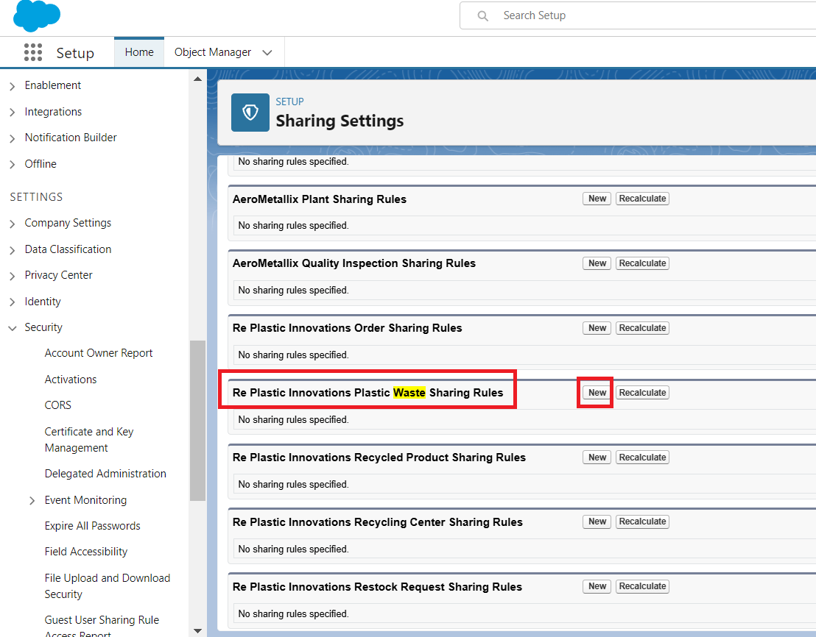

Activity: Create Sharing Rule – Sales Representative Access Purpose:
To grant read-only access to recycled product records for Sales Representatives.
Steps:
- Go to Setup → Sharing Settings
- Scroll to Re Plastic Innovations Recycled Product object

- Click New under Sharing Rules Enter the following details:
  - Label Name: Sales Representative Access
  - Rule Name: Sales_Representative_Access
  - Select which records should be shared: Records owned by CEO
  - Select the users to share with: Sales Representative
  - Access Level: Read Only
- Click Save

Activity: Create Sharing Rule – Warehouse Supervisor Access Purpose:
To grant read-only access to restock request records for Warehouse Supervisors.
Steps:
- Go to Setup → Sharing Settings
- Scroll to Re Plastic Innovations Restock Request object
- Click New under Sharing Rules Enter the following details:
  - Label Name: Warehouse Supervisor Access
  - Rule Name: Warehouse_Supervisor_Access
  - Select which records should be shared: Records owned by Sales Representative
  - Select the users to share with: Warehouse Supervisor
  - Access Level: Read Only
- Click Save

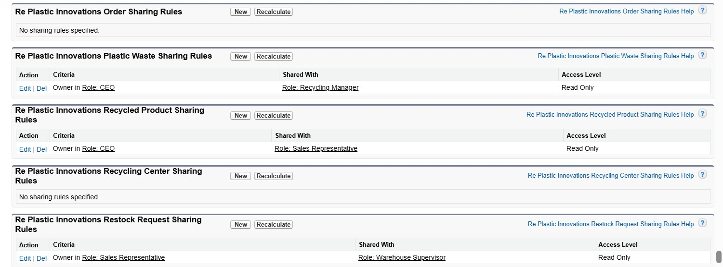

Outcome:
Record-level access is successfully configured using Sharing Settings and Sharing Rules. Recycling Managers, Sales Representatives, and
Warehouse Supervisors can now securely access only the records relevant to their roles within the Replastix Innovations Salesforce application.

Milestone 9: Create Formula Field – Stock Low On Product
Purpose:
To display a message indicating whether the stock level of a recycled product is low or sufficient based on the threshold value.
Steps to Create Formula Field:
- Go to Setup
- In the Quick Find box, search for Object Manager
- Select the object: Re Plastic Innovations Recycled Product
- Click Fields & Relationships
- Click New
- Select Data Type as Formula

- Click Next
Enter Field Details:
  - Field Label: Stock Low On Product
  - Data Type: Text
- Click Next
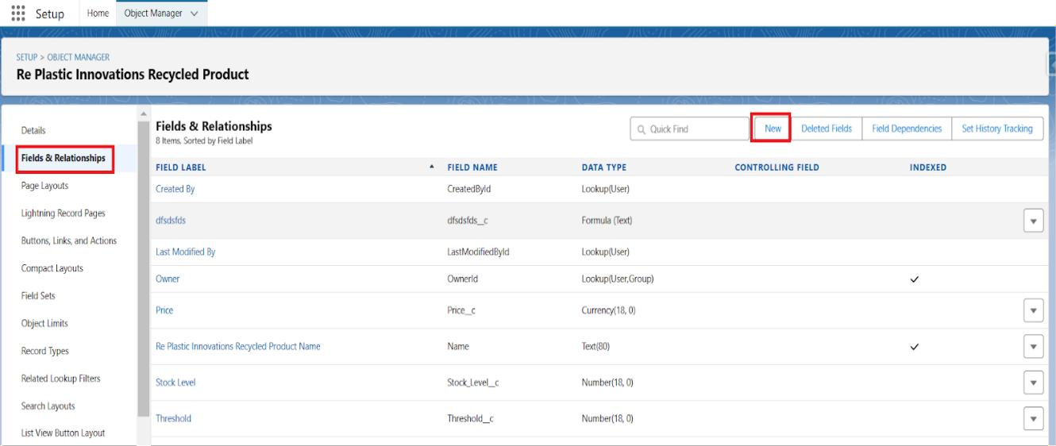
Formula Logic:
- Click Advanced Formula
- Enter the formula:
IF(Stock_Level c < Threshold c, "Low Stock - Restock Needed", "Sufficient Stock")
- Click Next
- Set Field-Level Security (keep default)
- Add the field to the page layout
- Click Save
Testing the Formula Field:
- Create or open a Recycled Product record
- Change the Stock Level value below the Threshold
- Verify the field displays: “Low Stock - Restock Needed”

- Increase the Stock Level above the Threshold and verify it shows: “Sufficient Stock”

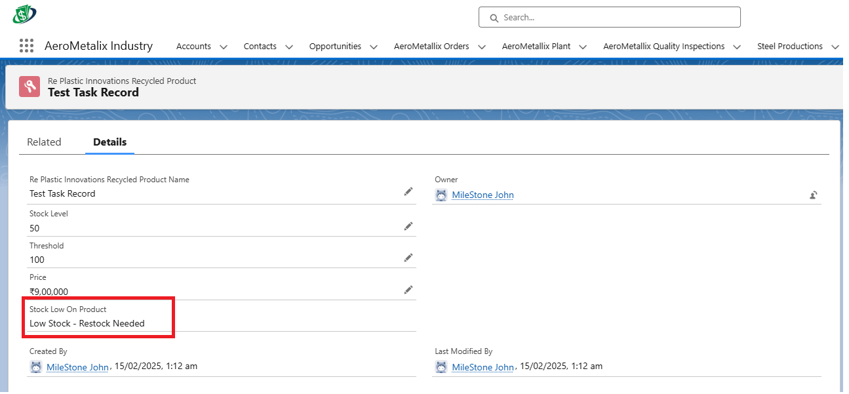

Activity: Create Validation Rule – Check_Quantity_Not_Zero Purpose:
To prevent users from creating an order with zero or negative quantity. Steps to Create Validation Rule:
- Go to Setup
- In the Quick Find box, search for Object Manager
- Select the object: Re Plastic Innovations Order
- Click Validation Rules
- Click New
Enter Validation Rule Details:
  - Rule Name: Check_Quantity_Not_Zero
  - Active: Checked

Formula:
Quantity c <= 0
Error Message:
Quantity must be greater than zero. Error Location:
Field: Quantity
- Click Save
Testing the Validation Rule:
- Create or edit an Order record
- Enter Quantity as 0 or a negative value
- Verify the error message is displayed
- Enter Quantity greater than 0 and save successfully

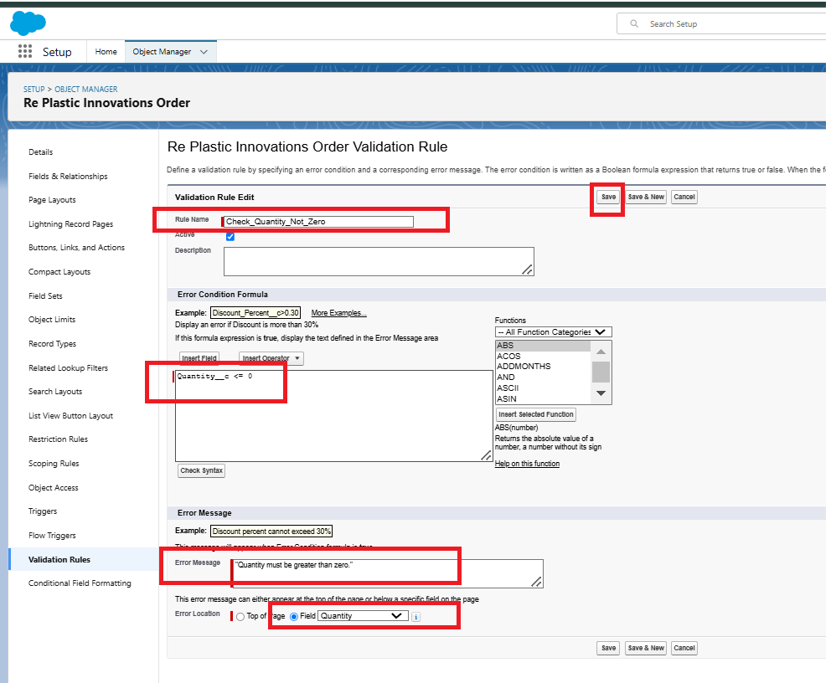
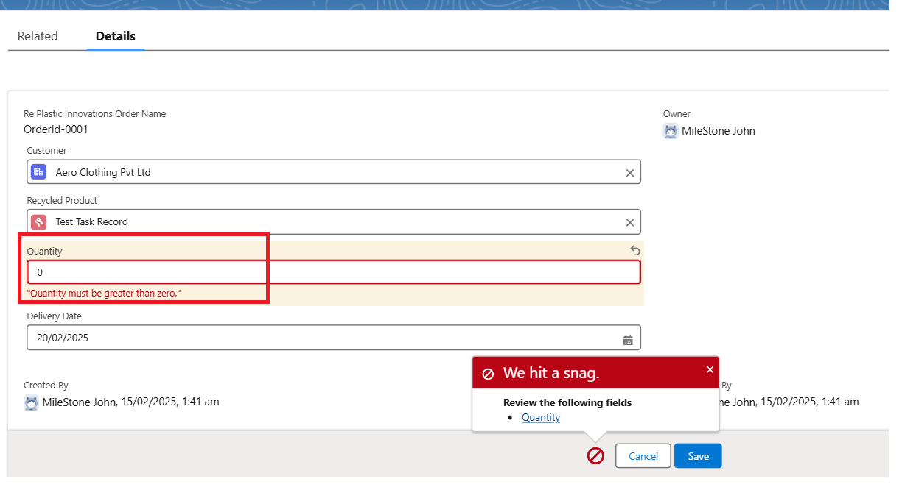

Activity: Create Validation Rule – Future_Date_Collection Purpose:
To prevent users from selecting a future date for plastic waste collection. Steps to Create Validation Rule:
- Go to Setup
- In the Quick Find box, search for Object Manager
- Select the object: Re Plastic Innovations Plastic Waste
- Click Validation Rules
- Click New
Enter Validation Rule Details:
  - Rule Name: Future_Date_Collection
  - Active: Checked Formula:
Collection_Date c > TODAY() Error Message:
Collection Date cannot be in the future. Error Location:

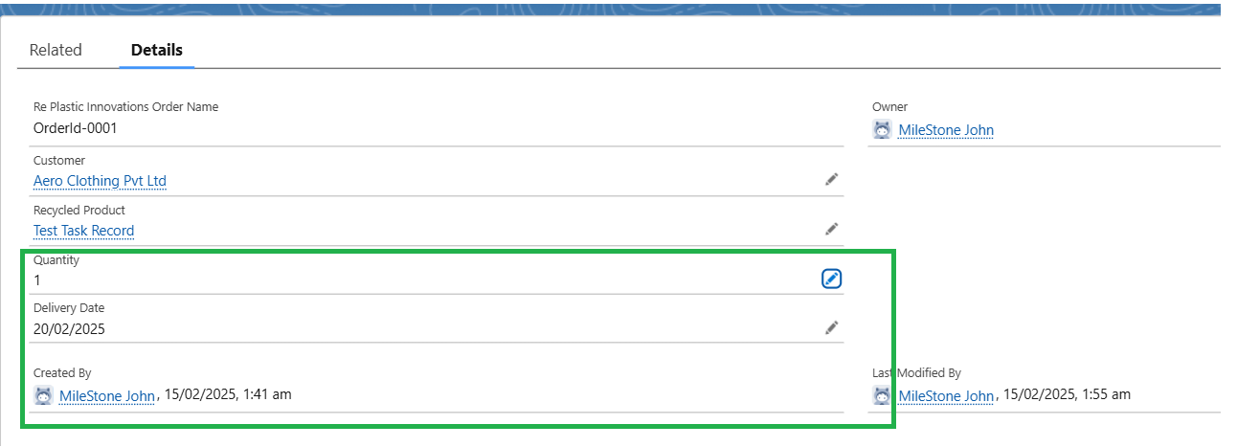
Field: Collection_Date c
- Click Save
Testing the Validation Rule:
- Create or edit a Plastic Waste record
- Enter a future date in Collection Date
- Verify the error message is displayed
- Enter today’s date or a past date and save successfully

Outcome:
The formula field and validation rules are successfully created, ensuring accurate stock visibility and enforcing correct data entry within the
Replastix Innovations Salesforce system.

Milestone 10: Flow Builder – Stock Level Monitoring
Purpose:
To create a scheduled flow that automatically checks recycled product stock levels daily and creates a task when stock falls below the threshold.

Steps to Create the Scheduled Flow:
- Go to Salesforce and click the Gear icon (top-right corner)
- Click Setup
- In the Quick Find box, type Flows
- Click Flows
- Click New Flow

Flow Type Selection:
- Select Start From Scratch
- Click Next
- Select Schedule-Triggered Flow
- Click Create

Schedule Configuration:
- Set Start Date: Today’s Date
- Set Start Time: 6:00 AM
- Set Frequency: Daily

Object Selection:
- Select Object: Re_Plastic_Innovations_Recycled_Product c
- Click Done

Add Decision Element:
- Click the Plus (+) icon
- Select Decision
- Enter Label Name: Decision 1 Outcome Details:
  - Outcome Label: Outcome 1 of Decision 1
  - Condition Logic: All Conditions Are Met (AND)
  - Condition:
    - Field: {!$Record.Stock_Level c}
    - Operator: Less Than

    - Value: {!$Record.Threshold c}
- Click Done

Add Create Records Element (Task Creation):
- Click the Plus (+) icon under the Decision outcome
- Search and select Create Records
- Enter Label: Create Task
- How to Set Field Values: Manually
- Create a Record of the Object: Task Set Field Values:
  - Assigned To ID: {!$Record.OwnerId}
  - Related To ID: {!$Record.Id}
  - Priority: High
  - Subject: Please look into this stock; stock is low. Fill the stock ASAP
  - Status: In Progress
- Click Done
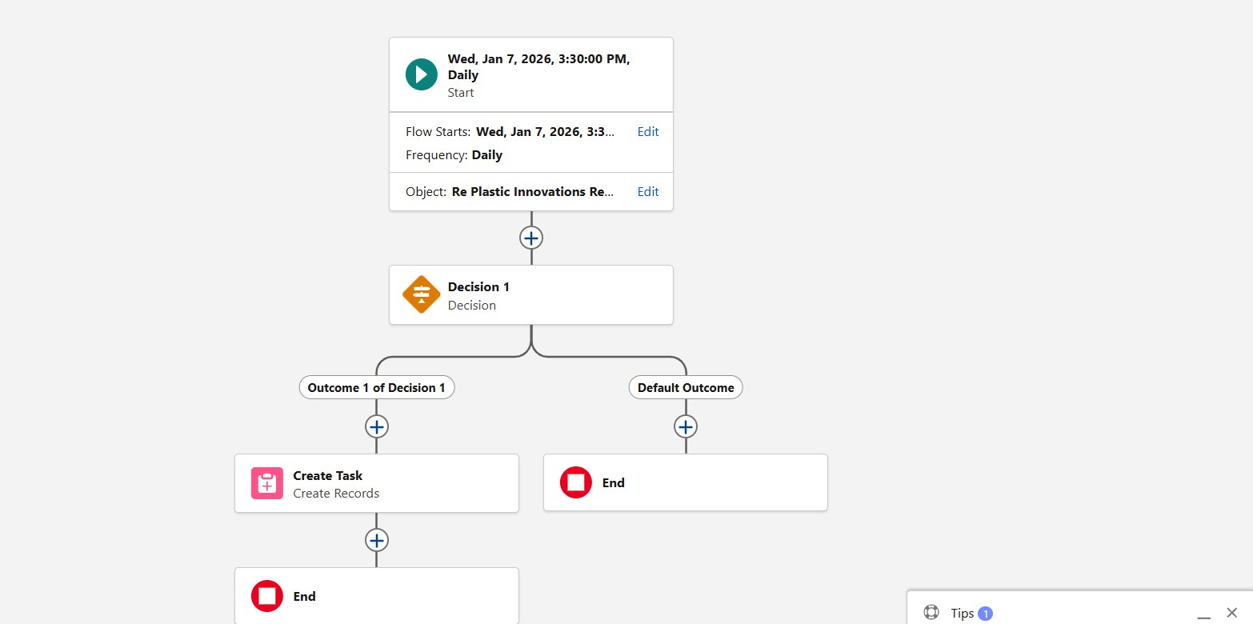

Save and Activate Flow:
- Click Save
- Enter Flow Label: Stock Level Is Low
- Click Save
- Click Activate

Testing the Flow:
- Create or edit a Recycled Product record
- Set Stock Level lower than Threshold value
- Wait for the scheduled time (6:00 AM)
- Navigate to the Task tab
- Click Upcoming & Overdue
- Verify that a new task is created and assigned to the record owner
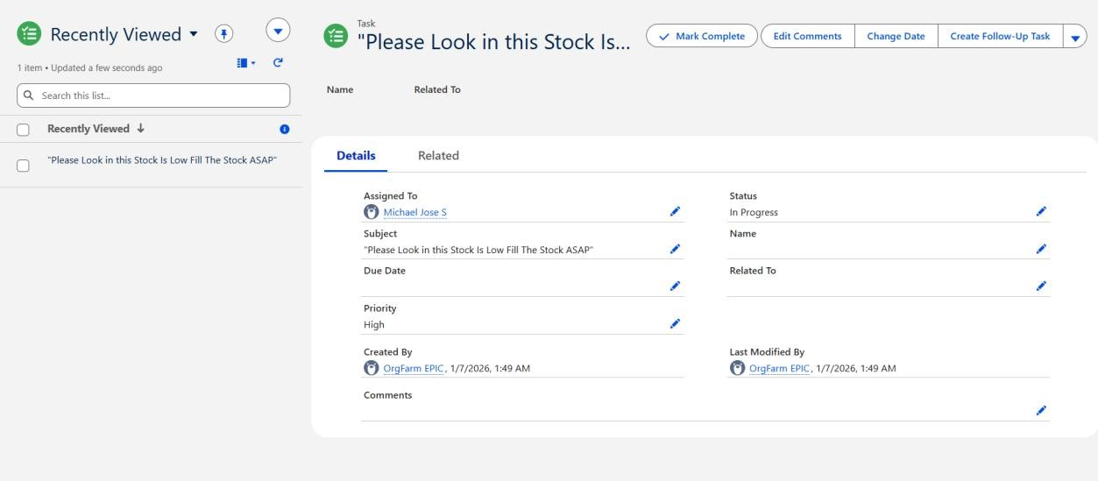

Outcome:
The scheduled flow successfully monitors stock levels daily and

automatically creates tasks when stock falls below the defined threshold, ensuring timely action and preventing stock shortages.

Milestone 11: Apex – Inventory Automation
Purpose
To automate inventory updates, restock request creation, approval handling, and email notifications using Apex classes and triggers in the Replastix Innovations Salesforce system.

Step 1: Create Apex Class – InventoryManager Steps to Create Apex Class
- Click the Gear Icon
- Select Developer Console
- Click File → New → Apex Class
- Enter Class Name: InventoryManager
- Click OK

Apex Class: InventoryManager public class InventoryManager {

// Method to reduce stock after order creation public static void
processOrderStock(List<Re_Plastic_Innovations_Order c> orderList) {

Set<Id> productIds = new Set<Id>();

for (Re_Plastic_Innovations_Order c order : orderList) { productIds.add(order.Recycled_Product c);
}

Map<Id, Re_Plastic_Innovations_Recycled_Product c> productMap =
new Map<Id, Re_Plastic_Innovations_Recycled_Product c>( [SELECT Id, Stock_Level c, Threshold c
FROM Re_Plastic_Innovations_Recycled_Product c WHERE Id IN :productIds]
);

List<Re_Plastic_Innovations_Recycled_Product c> productsToUpdate = new List<>();
List<Re_Plastic_Innovations_Restock_Request c> restockRequests
= new List<>();

for (Re_Plastic_Innovations_Order c order : orderList) { Re_Plastic_Innovations_Recycled_Product c product =
productMap.get(order.Recycled_Product c);

if (product != null) {
if (product.Stock_Level c >= order.Quantity c) { product.Stock_Level c -= order.Quantity c; productsToUpdate.add(product);
} else {

restockRequests.add(
new Re_Plastic_Innovations_Restock_Request c( Product c = product.Id,
Requested_Quantity c = order.Quantity c - product.Stock_Level c,
Status c = 'Pending'
)
);
}
}
}

if (!productsToUpdate.isEmpty()) { update productsToUpdate;
}

if (!restockRequests.isEmpty()) { insert restockRequests;
}
}

// Method to increase stock after restock approval public static void processRestockApproval(
List<Re_Plastic_Innovations_Restock_Request c> restockList) {

Set<Id> productIds = new Set<Id>();

for (Re_Plastic_Innovations_Restock_Request c restock : restockList) {
if (restock.Status c == 'Approved') { productIds.add(restock.Product c);
}
}

Map<Id, Re_Plastic_Innovations_Recycled_Product c> productMap =
new Map<Id, Re_Plastic_Innovations_Recycled_Product c>( [SELECT Id, Stock_Level c
FROM Re_Plastic_Innovations_Recycled_Product c WHERE Id IN :productIds]
);

List<Re_Plastic_Innovations_Recycled_Product c> productsToUpdate = new List<>();

for (Re_Plastic_Innovations_Restock_Request c restock : restockList) {
if (productMap.containsKey(restock.Product c)) {
Re_Plastic_Innovations_Recycled_Product c product = productMap.get(restock.Product c);
product.Stock_Level c += restock.Requested_Quantity c;

productsToUpdate.add(product);
}
}

if (!productsToUpdate.isEmpty()) { update productsToUpdate;
}
}
}

Step 2: Create Apex Trigger – UpdateStockAfterOrder Steps
- In Developer Console, click File → New → Apex Trigger
- Trigger Name: UpdateStockAfterOrder
- Object: Re_Plastic_Innovations_Order c
- Click Submit Trigger Code
trigger UpdateStockAfterOrder
on Re_Plastic_Innovations_Order c (after insert) {

InventoryManager.processOrderStock(Trigger.new);
}

Step 3: Create Apex Trigger – UpdateStockAfterRestockApproval Steps

- Click File → New → Apex Trigger
- Trigger Name: UpdateStockAfterRestockApproval
- Object: Re_Plastic_Innovations_Restock_Request c
- Click Submit Trigger Code
trigger UpdateStockAfterRestockApproval
on Re_Plastic_Innovations_Restock_Request c (after update) {

List<Re_Plastic_Innovations_Restock_Request c> approvedRestocks
=
new List<Re_Plastic_Innovations_Restock_Request c>();

for (Re_Plastic_Innovations_Restock_Request c restock : Trigger.new) {
if (restock.Status c == 'Approved' &&
Trigger.oldMap.get(restock.Id).Status c != 'Approved') { approvedRestocks.add(restock);
}
}

if (!approvedRestocks.isEmpty()) {
InventoryManager.processRestockApproval(approvedRestocks);

EmailNotificationHelper.sendRestockNotification(approvedRestocks);
}
}

Step 4: Create Apex Class – EmailNotificationHelper Steps
- Click File → New → Apex Class
- Class Name: EmailNotificationHelper
- Click OK Apex Code
public class EmailNotificationHelper {

public static void sendRestockNotification(
List<Re_Plastic_Innovations_Restock_Request c> restockRequests) {

List<Messaging.SingleEmailMessage> emails = new List<Messaging.SingleEmailMessage>();

for (Re_Plastic_Innovations_Restock_Request c restock : restockRequests) {
Messaging.SingleEmailMessage email = new Messaging.SingleEmailMessage();

email.setSubject('Restock Request Approved'); email.setToAddresses(
new List<String>{'mabdulrahaman066@gmail.com'}
);
email.setPlainTextBody(

'The restock request for product ' + restock.Product c +
' has been approved. Please proceed with stock update.'
);

emails.add(email);
}

if (!emails.isEmpty()) {
Messaging.sendEmail(emails);
}
}
}

Step 5: Testing the Apex Automation Test Scenario
- Create a Recycled Product record
  - Stock_Level c = 50
  - Threshold c = 100
- Create an Order record
  - Quantity c = 150
  - Select the above product
- Verify:
  - A Restock Request is automatically created
  - Status = Pending

- Open the Restock Request record
  - Change Status to Approved
  - Save the record
- Verify:
  - Product stock level is increased
  - Email notification is sent to warehouse manager
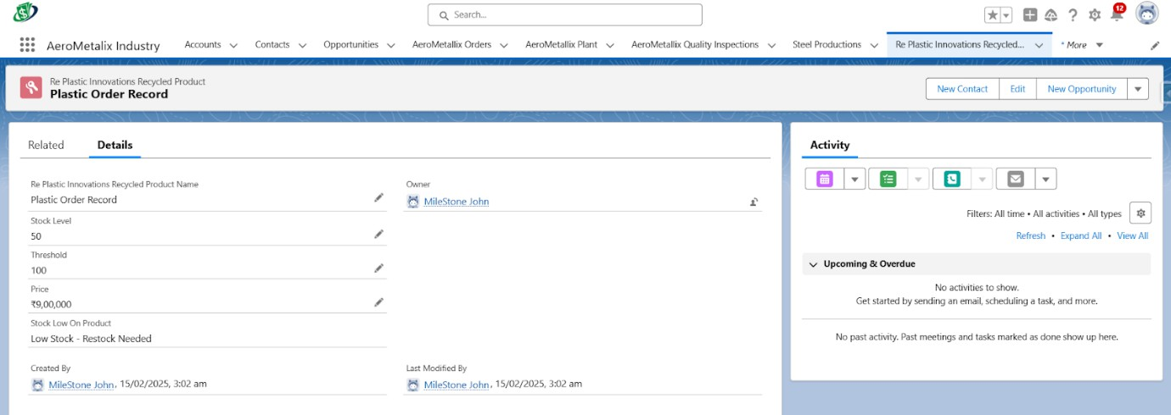

Step 6: Create Test Class – InventoryManagerTest Steps
- Click File → New → Apex Class
- Class Name: InventoryManagerTest
- Click OK Test Class Code @isTest
public class InventoryManagerTest {

@testSetup
static void setupTestData() {

Re_Plastic_Innovations_Recycled_Product c product = new Re_Plastic_Innovations_Recycled_Product c(
Stock_Level c = 50,
Threshold c = 10
);
insert product;

List<Re_Plastic_Innovations_Order c> orders = new List<Re_Plastic_Innovations_Order c>{ new Re_Plastic_Innovations_Order c(
Recycled_Product c = product.Id, Quantity c = 20
),
new Re_Plastic_Innovations_Order c( Recycled_Product c = product.Id,
Quantity c = 40
)
};

insert orders;
}

@isTest
static void testProcessOrderStock() {

List<Re_Plastic_Innovations_Order c> orders = [SELECT Id, Recycled_Product c, Quantity c FROM Re_Plastic_Innovations_Order c];

Test.startTest();
InventoryManager.processOrderStock(orders); Test.stopTest();

Re_Plastic_Innovations_Recycled_Product c product = [SELECT Stock_Level c
FROM Re_Plastic_Innovations_Recycled_Product c];

System.assertNotEquals(null, product.Stock_Level c);
}

@isTest
static void testProcessRestockApproval() {

List<Re_Plastic_Innovations_Restock_Request c> restocks = [SELECT Id, Product c, Requested_Quantity c
FROM Re_Plastic_Innovations_Restock_Request c];

for (Re_Plastic_Innovations_Restock_Request c req : restocks) { req.Status c = 'Approved';
}

Test.startTest(); update restocks; Test.stopTest();

Re_Plastic_Innovations_Recycled_Product c product = [SELECT Stock_Level c
FROM Re_Plastic_Innovations_Recycled_Product c];

System.assert(product.Stock_Level c > 0);
}
}

Final Outcome
- Inventory automation implemented using Apex
- Stock reduction and replenishment handled automatically
- Restock approval updates product stock
- Email notifications sent to warehouse manager
- Apex test class executes successfully with high coverage

Project Conclusion
The Replastix Innovations Salesforce Automation project successfully demonstrates the implementation of a comprehensive, real-world CRM solution tailored for plastic waste management and recycling

operations. By leveraging the Salesforce platform, the project effectively automates key business processes such as inventory tracking, order
management, restock handling, and role-based data access, thereby reducing manual effort and improving operational efficiency.
Throughout the project, a well-structured data model was designed using custom objects, fields, and relationships to accurately represent recycling workflows. Robust data security was ensured through the implementation of roles, profiles, users, sharing rules, and record-level access controls, allowing each user to access only the data relevant to their responsibilities. This approach enhanced both system security and user experience.
Automation played a central role in the project. Scheduled Flows were used to monitor stock levels and generate tasks proactively when
inventory fell below defined thresholds. Apex classes and triggers were implemented to handle complex business logic such as automatic stock deduction upon order creation, restock request generation, stock
updates after approval, and email notifications to warehouse managers. These automations ensured timely actions and minimized the risk of stock shortages.
Validation rules and formula fields were introduced to maintain data accuracy and enforce business constraints, preventing incorrect data entry and providing real-time visibility into stock conditions.
Comprehensive Apex test classes were developed to validate the functionality of triggers and classes, ensuring reliable execution and sufficient test coverage.
Overall, this project provided valuable hands-on experience with Salesforce development, including data modeling, security
configuration, automation using Flow Builder and Apex, and real-time process integration. The Replastix Innovations system serves as a
scalable and efficient solution that supports sustainable waste
management operations while showcasing the practical application of Salesforce in solving complex business.

